

**Kinetrac DAVINCI User’s Manual**

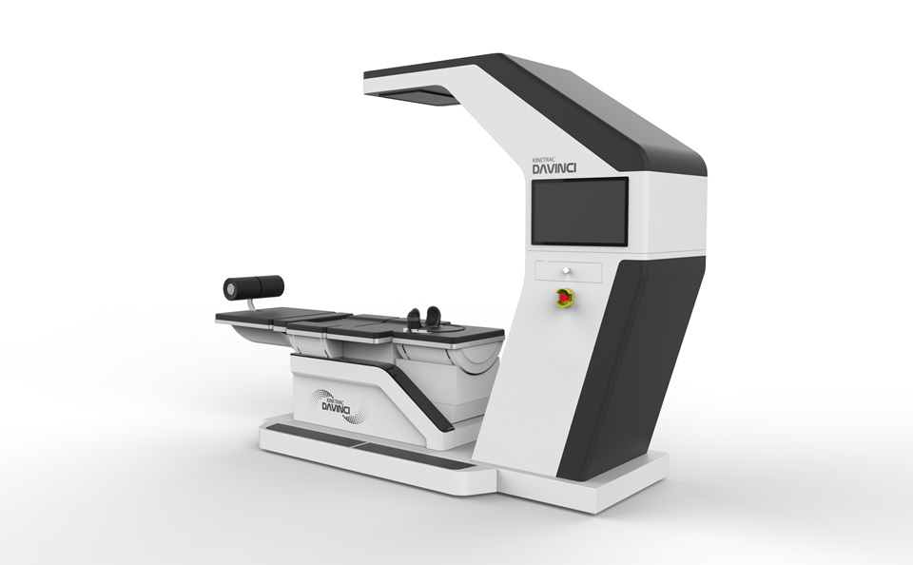

### B-101, 80-121, Golden Root-ro, Juchon-myeon, Gimhae-si, Gyeongsangnam-do, 50969, KOREA



• Phone +82-55-331-0575 • Fax +82-55-331-0547

**www .hanm ed.n et**

Technical Support

[kinetrac@naver.com](mailto:kinetrac@naver.com)

**Introduction**

### Introduction 3

About the Kinetrac Davinci 3 **Intended Use 4**

## The Whole Package 4

1. Exterior of main part 6
2. Control Part 7

**Setup Instruction 8**

1. How to assemble part for lower body 8
2. Location of control equipment 9
3. How to connect each CABLE 10
4. Function on Manual Operation window 11

**Efficiency 12**

1. Capability(spec.) 12

1. Standard voltage and frequency12
2. Power consumption12
3. Function 12

**Use Purpose 16**

1. Disc Navigation Targeting Decompression system 16
2. Correct muscles on pelvis, spine,

lower legs and cervical vertebral part

17

**Preparations before Using 18**

**Setup Instructions 19**

1. Basic Operating Instructions 19
2. Patient registration 19

* Window to enter patient Data 20
* Tx. Menu screen 23
* Status Display screen 29
* How to operate theSetup window

**Maintenance 40**

1. How to maintain 40
2. Prevention method 41
3. Disposal 42

**Service Maintenance/ Cleaning Log Precautions 43**

1. Warning 45

**Warranty 46**

Service and Warranty 48

Technical Support 48





Most people today experience spine-related diseases, which appear in various age groups due to increased sedentary hours at a desk and mobile phone use. As more patients visit hospitals for treatment of spinal disorders, higher quality, more quantitative and more stable treatments are required.

Representing advanced design and technology, Kinetrac Davinci was designed for stable quantitative traction without an unintentional increase or decrease of traction exerted on the body, even with any movements of the spine, pelvis and lower limbs during a distraction.

This product implements various treatment patterns through quantitative traction that were not available in the past, which include traction with lordosis along the spinal curve, simultaneous motions of traction and twisting of the spine, as well as stretching of the psoas muscles to relieve pressure on the disc. You will see the excellent treatment effects through spinal alignment, disc decompression, and treatment of the surrounding muscles.

Its user interfaces are configured for easier and more convenient operation and application to relieve overall spinal disorders.

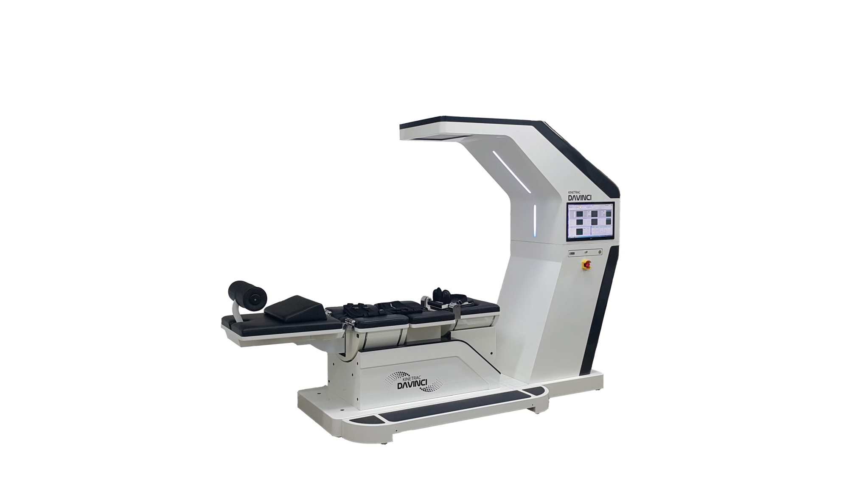

**Kinetrac DAVINCI**



## Intended Use

### Kinetrac Davinci has been developed with doctors’ prescriptions and advanced technology. It is designed for stable quantitative traction without an unintentional increase or decrease of traction exerted on the body even with any movements of the spine, pelvis and lower limbs during a distraction. This product performs the appropriate movements required for a variety of spinal disorders.

You can experience the effects of relaxed spinal muscles through traction with lordosis technology for maximum disc decompression, simultaneous motions of traction and twisting of the spine, as well as simultaneous motions of traction and curved stretching of the pelvic limbs. This device is highly effective for the treatment of musculoskeletal pain in the spine related to disc herniation (HNP: herniation of nucleus pulposus), protruded discs, degenerative discs, posterior facet syndrome and sciatica.

**Essential Performance**

* Distraction (C-spine, L-Spine)
* Distraction With Target Lordosis Of L-Spine
* Distraction With Twist (C-spine, L-spine)
* Distraction With Extension/Flexion Of C-Spine
* Distraction With Extension/Flexion Of Lower Limb
* Height Short & Long Control

**Symbols marked on the system**

|  |  |  |
| --- | --- | --- |
| No | Symbol | Description |
| 1 | EMB0000064c12dc | Type B Applied Part |
| 2 | EMB0000064c12dd | Refer to The Manual |
| 3 | EMB0000064c12de | Warning |
| 4 | EMB0000064c12df | Emergency Stop |
| 5 | EMB0000064c12e0 | Protective Earth |
| 6 | EMB0000064c12e1 | EU Representatives Information |
| 7 | EMB0000064c12e2 | Manufacturer Information |
| 8 | EMB0000064c12e3 | Made Date |
| 9 | EMB0000064c12e4 | Serial Number |
| 10 | EMB0000064c12e5 | Electronics Disposal Information |
| 11 | EMB0000064c12e6 | Alternating Current Power Source |
| 12 | EMB0000064c12e7 | Power Switch |

**Symbols marked on the Packaging of the system**



|  |  |  |
| --- | --- | --- |
| 1 |  | Keep dry |
| 2 |  | Upper side symbol |
| 3 |  | Fragile, handle with care |

**Compliance according to IEC 60601-1**

|  |  |
| --- | --- |
| Protection Method Against Electric Shock | Class I equipment |
| Degree of Protection Against Electric Shock | Type-B equipment |
| Operation Mode | Continual operation |
| Degree of Protection Against Liquid Ingress | Ordinary equipment |
| Use in Flammable Atmosphere | Not to be used in presence of flammable anesthetics gas |

**Marking plate**

Attachment position: the bottom of the back side of the main body

|  |  |  |  |  |  |  |  |  |
| --- | --- | --- | --- | --- | --- | --- | --- | --- |
| **Product**  **Name (Type):** | | Orthopedics appliance  ***Kinetrac DAVINCI*** | | | | | EMB000007ec1179 | |
| **License No. :** | | |  | | | | | |
| **Protection Class :** | | | Class I, Type B | | | **Weight :** | | 450kg |
| **Rating :** | | | 220~230V, 50/60Hz, 500 VA | | | | | |
| EMB000007ec117a  **Serial Number** |  | | | EMB000007ec117b  **MFG. Date** |  | | | EMB00002a4c59db  **1370**  EMB000007ec117c  EMB000007ec117d |
| EMB000007ec117e  **Manufacturer** | B-101, 80-121, Golden Root-ro, Juchon-myeon, Gimhae-si, Gyeongsangnam-do, 50969, KOREA TEL:+82-55-331-0575 FAX:+82-55-331-0547 | | | | | | |
| EMB000007ec117f  **Authorized**  **EC representative** | D.M. Consulting srl  Viale del Lavoro, 7  35010 Vigonza (PD),  **ITALY** | | | | | | |
| EMB000007ec1180 | **This product is a medical device.**  Please read the user’s manual carefully before use. | | | | | | |

1. **Photos of Appearance**

|  |  |  |  |
| --- | --- | --- | --- |
| ① Front | | | |
| ② | Side  EMB000035104fbb | ③ | Rear  EMB000035104fbe |
| 4 | Rear  EMB000035104fc1 | | |

1. **Description of Appearance**

|  |  |  |
| --- | --- | --- |
| ① Front  EMB000022cc066b | | |
| ② Rear    EMB000022cc0697 | ③ Side  EMB000035104fc4 | |
| ④ Lower extremities support cushion  EMB000004ec03f1 | | ⑤ Detecting sensor    EMB000004ec03f4 |

1. The twist(left-light rotation) driving part of the cervical spine
2. Cervical strap and cushion for twist
3. Bed cushion of thoracic spine
4. Chest strap and cushionl.
5. The twist(left-light rotation) driving part of the lumbar spine
6. The compression part of lumbar spine : A pressing part using a cushion ball
7. Pelvic limb strap and cushion for twist.
8. A switch to adjust the length of the pelvic limb cushion.
9. Ankle strap and cushion.
10. Ankle cushion : To comfort the ankle area when it is held to a patient's ankles.

This is a device to hold a patient's ankles while the device is running.

1. Monitor
2. Controlling keyboard : This is used to set the operational functions and enter commands.
3. Emergency switch : Use this to stop the device.
4. Computer controller: ON/OFF switch
5. Main power switch
6. Control box
7. Main power input connecter
8. Lower extremities support cushion
9. Detecting sensor

**※Note**

Applied part - Part of ME EQUIPMENT that in NORMAL USE necessarily comes into physical contact with the PATIENT for ME EQUIPMENT or an ME SYSTEM to perform its function (According to IEC 60601-1 Ed3.1)

**Environmental Conditions**

Operating Environment

* + - Ambient temperature : 10℃ to 40℃
    - Relative humidity : 30% to 75%
    - Atmospheric pressure : 800hPa to 1060hPa Transportation and Storage Environment
    - Ambient temperature : -40℃ to 70℃
    - Relative humidity : 10% to 100%, including condensation
    - Atmospheric pressure : 500hPa to 1060hPa

## Patient Environment

The control box must be kept outside the patient environment. (refer to IEC 60601-1)

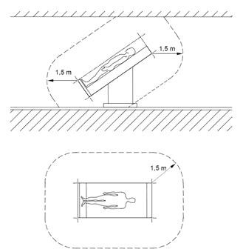

Patient Environment



**Trial Operation after Connection** (Fig. 12)

## Doing a test run after installation and connection

### Turn on the power to the PC and double-click the Davinci icon to run the program. Turn on the power to the device and click the Setup tab on the top menu of the Davinci program screen. When the Setup tab appears as shown in the picture, test the motor movement for each function in the lower part of Manual Operation. Click the buttons from Motor 0 to Motor 7 to see whether the motor is working normally. As for Motors 0, 1, 2, 5 and 6, the numbers (0) in the center change when the motors are running.

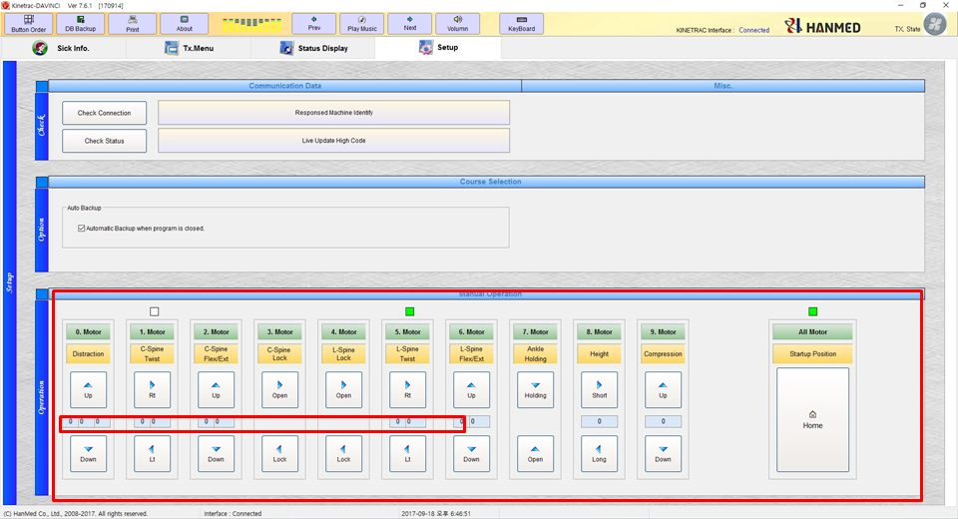

* 1. After confirming that the motors are working well, click the Home button on the right. Then all the motors return to the initial state (Home state) to get ready for operation.



### **1. Performance (Specifications)**

1. Rated voltage and frequency: AC100-240V, 50Hz / 60Hz
2. Power consumption: 300W
3. Traction - Range of traction: 0Kg ~ 45Kg ± 10% or 2Kg (C&L Spine)

(4) Distraction With Target Lordosis Of L-Spine :

|  |
| --- |
| EMB00002a4c59ec EMB00002a4c59ed |
| - Lumbar Spine Target Detection Performance : ±10mm  - Lumbar Spine Rise Compression action : 50mm ±10mm |

(5) Distraction With Twist Of L-Spine :

|  |  |  |
| --- | --- | --- |
| EMB000022cc0788 | | EMB000022cc078b |
|  | - Rotation angle Rt & Lt : 0~17° ±2° | |

(6) Distraction With Extension/Flexion of Pelvic(hip joint) :

|  |
| --- |
| EMB00002a4c5a00 |
| - Extension angle : 0~25° ±3° |

(7) Distraction With Twist of Cervical Spine :

|  |  |
| --- | --- |
| EMB00002a4c5a0b | EMB00002a4c5a0c |
| - Rotation angle Rt & Lt : 0~17° ±2° | |

(8) Distraction With Extension/Flexion of Cervical Spine :

|  |  |
| --- | --- |
| EMB00002a4c5a11 | EMB00002a4c5a12 |
| - Extension angle : 0°~ 15° ±2° | |

(9) Height Short & Long Control :

- Short & Long : 0~200 ±10mm

(10) Input power fluctuations: ±10%

(11)Safety device: It is designed to achieve reinforced insulation in addition to basic insulation.

* 1. Circuit breaker: Prevents overcharging
  2. Emergency stop button for emergency operation: A device used to stop the operation in an emergency.

|  |  |
| --- | --- |
| EMB000022cc07b8 | EMB00002a4c5a1b |
| - Emergency switch and stop button on the monitor (press the button to stop)  operation) | |

* 1. Home return device: In the case of an abnormal operation or emergency, press the Home button of the program to stop the device and automatically return all operations to the starting point.



## Alignment of the Human Body

### A67030.01 Corrective orthotic device [2] An orthopedic appliance used to reposition the human body.

A67010.03 Electrical orthopedic traction device [2] A traction unit that is electrically powered for treating disc herniation, degenerative stenosis, etc.

1. This system is a precision piece of medical equipment designed to reposition (align) the human body.
2. It can be used not only for disc pain relief but also for a wide range of musculoskeletal disc

discomfort.

1. It may also be used for maintenance care.



### Check the voltage for your country.

* This product is used on 220-240V, 50 and 60Hz.

1. Make sure all the cords are accurately connected.

(※ Caution: Incomplete or loose connections may generate heat and cause a fire.)

1. Make sure the device is properly grounded.
2. Check the switch connections.
3. The device should only be operated by a trained person.
4. Make sure that there are no unnecessary objects around the device.
5. If the device is located near equipment which emits strong electromagnetic waves, this may cause the device to malfunction.

**WARNING : To avoid the risk of electric shock, this equipment must only be connected to a supply mains with protective earth.**

|  |  |
| --- | --- |
| EMB000022cc07be | EMB000022cc07c1 |

**Starting and Shutting Down the System**

To turn on the system, do the following:

Press the ON switch on the side of the control box.

To turn off the system, do the following:

Press the OFF switch on the side of the control box.

**※Note:** The Main power cable is a means to isolate its circuits electrically from the SUPPLY MAINS on all poles simultaneously.



## Basic Operating Instructions

## 1) Starting and Shutting down the system

(1) Turn on the power and run the program. Main power and desktop power button located on right side control panel.

|  |  |
| --- | --- |
| EMB00001d5429a8 | EMB00001d5429a9 |

(2) Set up the patient record, procedure time and intensity, and treatment site in control panel.

Check the safety of the devide and its surroundings.

(3) Patient lay on the bed. The cervical, thoracic, and pelvic regions of patient are fixed by harness

-If lumbar compression is required, attach a detecting sensor to the treatment site.

(4) Adjust to the patient's height by and harness length buttons, and then fix the ankle.

|  |  |  |
| --- | --- | --- |
| EMB00001d5429aa | EMB00001d5429ab | EMB00001d5429ac |

(5) Treatment is started by pressing the START button after setting the treatment condition of cervical or lumbar spine.

(6) The procedure intensity can be adjusted according to the patient condition during DAVINCI operating.

(7) You should care closely at patient's condition during treatment period.

(8) Pressing the emergency stop button(red color), turn the switch clockwise will stop the operation and automatically return to the initial state in emergency.

(9) When the treatment is finished, it automatically returns to the initial state.

(10) To shut down the DAVINCI, turn off the power swtich on the back of the control box and shut down the desktop.

(11) Disconnect the power plug completely from the utility power supply.

**※Note :** The Main power cable is a means to isolate its circuits electrically from the SUPPLY MAINS on all poles simultaneously.

**WARNING :** To avoid the risk of electric shock, this equipment must only be connected to a supply mains with protective earth

※ NOTICE : The mains cable is a means of electrically isolating the SUPPLY MAINS of all poles from the circuit.



**Important!**

There are four major groups of monitor screens in the system. These are: **Sick Info**, **Tx. Menu**, **Status Display** and **Setup**. Along with entering patient information, they indicate how to make appropriate care procedures (patterns) as well as operate the bed correctly based on input data. They are described in detail below, from the **Sick Info** screen through the **Setup** screen.

* + Sick Info • Tx. Menu

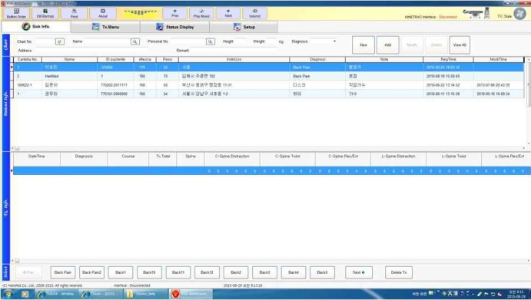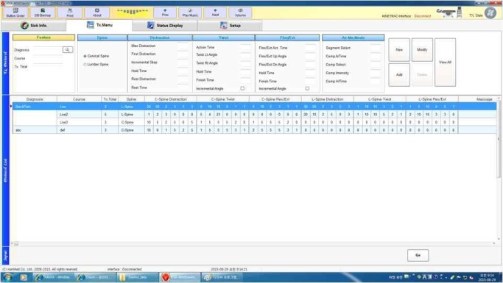

* Status Display • Setup

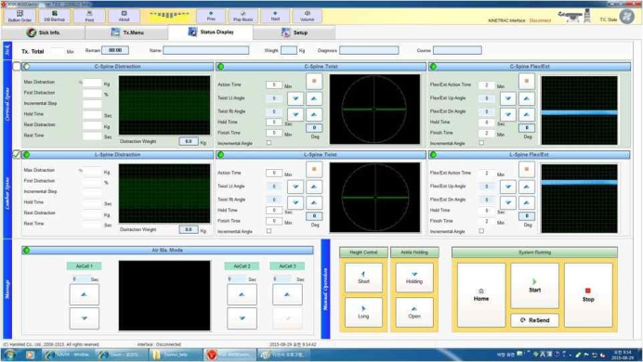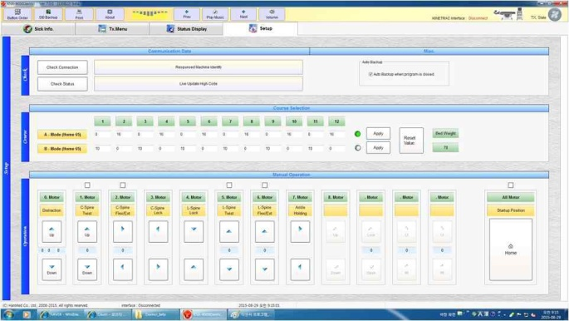

1. Descriptions about the Sick Info screen (patient’s personal information)

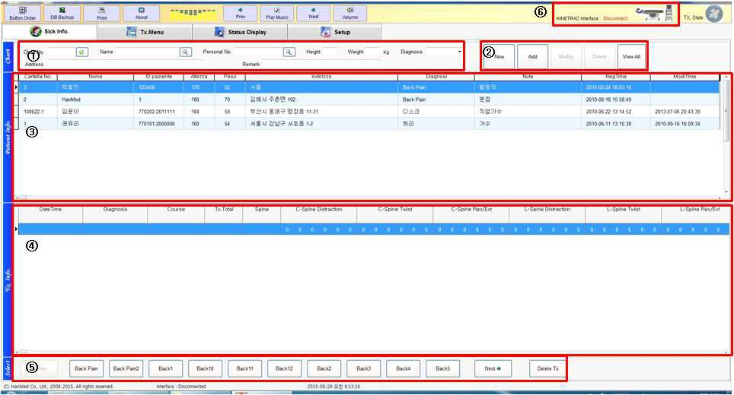

### ① This is where you input a patient’s personal information.

② Icons to save, delete or modify a patient’s personal data.

③ Patient data display window (list of patients’ data)

④ A window to show the treatment records of patients

⑤ Icons to select or delete a treatment pattern

⑥ Icons to check the communication connection between the device and the controlling computer

1. **How to input patient information.**



(1) **Chart No**. Enter a medical chart number in the blank.

(2) **Name**  Enter the patient’s name in the blank.

(3) **Personal No**. Enter the resident registration number in the blank.

(4) **Height** Enter the patient’s height (cm) in the blank.

(5) **Weight** Enter the patient’s weight (kg) in the blank.

(6) **Diagnosis** The doctor may enter the name of a disease or choose one of the created commands.

(7) **Address** Enter the patient’s address in the blank.

### (8) **Remark** Enter special notes about patient.

1. **How to create, save, modify and delete the patient information (data).**



(1) **New** . Press this button to enter new patient data.

(2) **Add.** Press this button to add the newly created patient data through the **New** button.

(3) When there is a modification to the patient data, press the **Modify** button to save the modification. You cannot revise the Chart No.

(4) When you need to delete a patient’s data, select the patient (data) and

press the **Delete** button to delete it.

(5) While the search results by Chart No., Name and Personal No. show specific patients only,

the **View All** button displays the full list of patients.

1. **Patient data display window (list of patients) as shown in the screen description in ③ above**

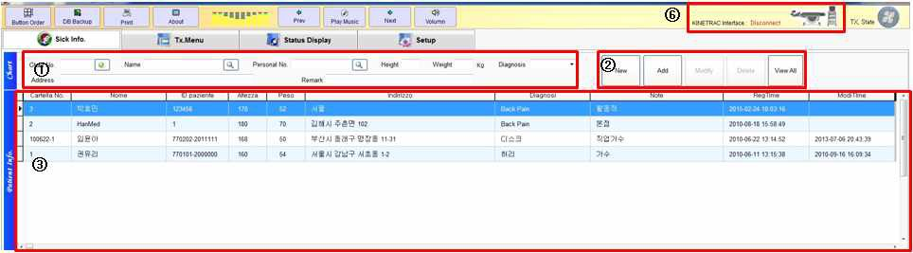

1. Depending on the input method of patient information, the information is created in the patient information window in ③.
2. Click on the patient information to select a patient and double-click it to switch to the Tx. Menu screen.
3. **A window to show the treatment records of patients as per the screen description in ④**

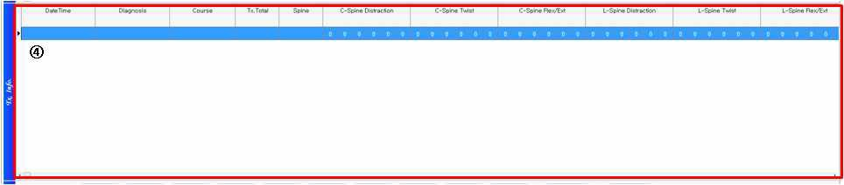

1. When a treatment session is over, the content is automatically recorded as shown in the screen description in ④, treatment records of the patient.
2. The latest treatment is displayed at the top. When you want to apply the same treatment, double-click it to display the treatment pattern information in the Status Display screen.
3. **Icons to select or delete a treatment pattern**



1. The Diagnosis of the treatment pattern created in the Tx. Menu appears as a button in the screen description ⑤ at the bottom of the Sick Info window.
2. When you double-click the newly created button, the screen switches to the Tx. Menu and the matching treatment pattern for the Diagnosis is displayed.

To delete the diagnosis, press the **Delete Tx** button

1. **Tx. Menu Setting Screen Description**

-The Tx. Menu is a window used to set the operating range of the device as per a user’s preferences.

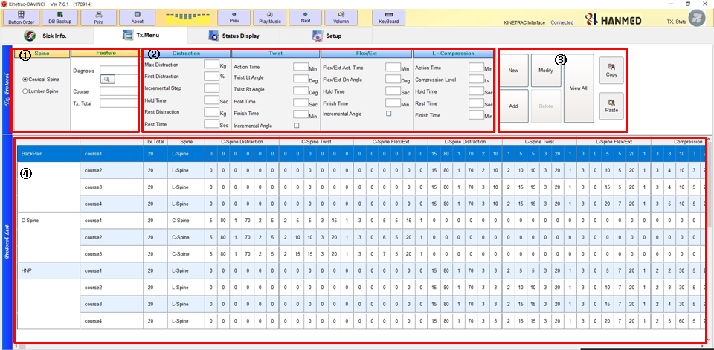

### ① Feature input section - Enter the title to identify the symptoms and motion (care) types here.

② Data input section - Enter duration and intensity (forces) here.

③ Selection buttons to determine whether to save, modify, view or delete a treatment pattern.

④ A window to show the predefined treatment pattern.

1) Spine & Feature

* This is used to name the symptoms to distinguish them and assign an appropriate treatment pattern to each symptom.

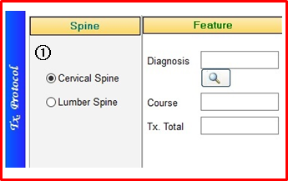

1) Feature section.

- Selected the treatment region of cervical or lumbar spine

- In Diagnosis column, enter an optimal diagnosis name(treatment pattern) represent the symptom evaluated.

- In Course column, enter the application stage of the treatment pattern.

- In Tx. Total column, enter the total treatment time(0-99 input available)

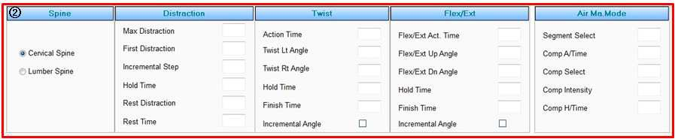**2) Data input section for duration and intensity (forces) of the device operation**

1. 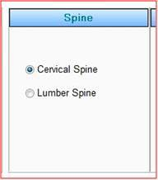**Spine - Enter the body part to be treated**

① Cervical Spine: Select this for a cervical spine treatment.

② Lumbar Spine: Select this for a lumbar spine treatment.

1. **Distraction - Set the distraction details including intensity, duration, pattern, etc.**

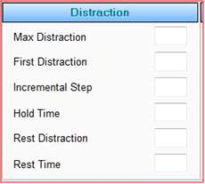

① Max Distraction: Enter the maximum distraction force here. (Up to a maximum of 45kg)

② First Distraction: Enter the initial distraction force here.

The value is expressed as a percentage compared with the maximum distraction force.

e.g., when you enter 10 here, the device starts with 10% of the Max Distraction force.

when you enter 20 here, the device starts with 20% of the Max Distraction force. (Enter a value from 0 to 99.)

③ Incremental Step: Enter distraction force to be added for each step of action from the initial

to the maximum intensity (Enter a value from 0 to 9.).

e.g., when you enter zero (0), the initial distraction force directly changes to the maximum value in the second step.

When you enter 1, the distraction force in the second step will be initial value + (maximum value - initial value) * 1/2. From the third step, the maximum distraction will be used.

When you enter 2, the distraction force in the second step will be initial value + (maximum value - initial value) * 1/3. The third step distraction will be initial value + (maximum value - initial value) * 2/3. From the fourth step, the maximum distraction will be used.

④ Hold Time: Enter the duration of a pause (sec) in a distracted state. (Enter a value from 0 to 99.)

⑤ Rest Distraction: Enter the distraction force during a break after releasing the distraction applied during the hold time. (Enter a value from 0 to 50kg.)

⑥ Rest Time: Enter the duration of a pause (sec) in a state of Rest Distraction. (Enter a value from 0 to 99.)

**(3) Twist - Sets up the angle and duration for a twist action.**

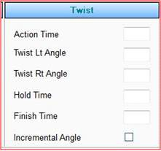

① Action Time: Enter the start time (min) of a twisting motion after pressing the Start button to run the device (Enter a value from 0 to 99.).

② Twist Lt Angle: Enter the angle of rotation to the left side. Enter the angle from 0 to 20 in units of 5 degrees.

③ Twist Rt Angle: Enter the angle of rotation to the right side. Enter the angle from 0 to 20 in units of 5 degrees.

④ Hold Time: Enter the duration of a pause (sec) in a twisted state. (Enter a value from 0 to 99.)

⑤ Finish Time: Enter the end time (min) of a twist action.

When the device reaches the end time, the twist action ends and no longer occurs during the

remaining Tx. time.

(Enter a value from 0 to 99.)

⑥ Incremental Angles: Here you can set the action mode up to the set angle.

(When you select this mode, the device angle starts at 5 degrees and is added by 5 degrees until it reaches the set angle, and from this moment the angle remains the same.

When you deselect this mode, the set angle is applied from the start.

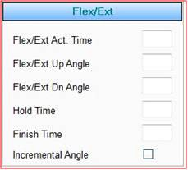**(4) Flex/Ext - Sets up angles and duration of a Flexion/Extension action**

① Flex/Ext Act. Time : Press the Start button to run the device and then enter the start time (min) of an up-and-down motion. (Enter a value from 0 to 99.).

② Flex/Ext Up Angle : Enter the angle of an upward motion. Enter the angle from 0 to 10 in units of 5 degrees.

③ Flex/Ext Dn Angle : Enter the angle of a downward motion. Enter the angle from 0 to 15 in units of 5 degrees.

④ Hold Time : Enter the duration of a pause (sec) in a Flex/Ext state. (Enter a value from 0 to 99.)

⑤ Finish Time : Enter the end time (min) of a Flex/Ext action.

When the device reaches the end time, the Flex/Ext action ends and no longer occurs during the remaining Tx. time.

(Enter a value from 0 to 99.)

⑥ Incremental Angles : Here you can set the action mode up to the set angle. (When you select this mode, the device angle starts at 5 degrees and is added by 5 degrees until it reaches the set angle, and from this moment the angle remains the same.

When you deselect this mode, the set angle is applied from the start.

**(5) L-Compression Mode**

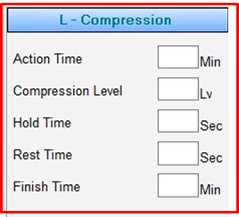

① Action Time : Enter the time at which the cushion ball starts to move up and down for compression of the lumbar spine(0-99 input available)

② Compression Level : Enter the vertical height of move up and down of the cushion ball(10-55mm)

③ Hold Time : Enter the time to keep the compression state by cushion ball

④ Rest Time : Enter the time to keep the relax time after move down of cushion ball

⑤ Finish Time : Enter the time at which the cushion ball finishes to move up and down for compression of the lumbar spine(0-99 input available)

1. Use these buttons to create, modify, view or delete a treatment pattern.

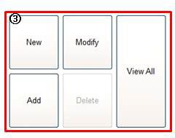

① New : Press this button to create a new treatment pattern.

② Add : Click this button to save a treatment pattern after filling out the content.

③ Modify : Click this button to amend an existing treatment pattern.

④ Delete : Click this button to delete an existing treatment pattern.

⑤ View All : Use this button to see all the existing treatment patterns, if you can only find part of the list when you search by the name of a treatment pattern.

1. Tx. pattern screen - Double click a pattern to display the Status Display screen of the pattern.

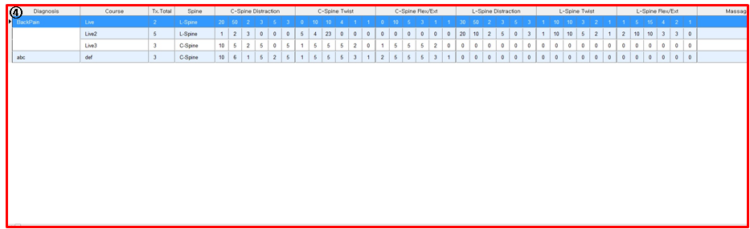

## Descriptions about Status Display Screen

### - A window to show the care action in real time. You can modify or stop the action.

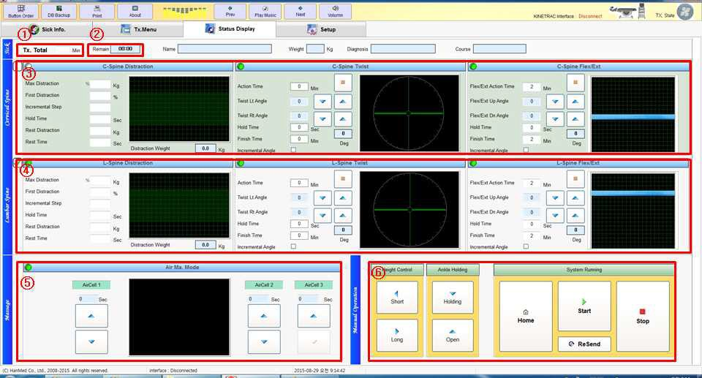

① Tx. Total: The duration of a care session appears here.

② Remain: The remaining time for a session timeout is displayed here during a session.

③ Cervical Spine: This screen shows the details of a cervical spine treatment.

④ Lumbar Spine: This screen shows the details of a lumbar spine treatment.

⑤ Air Ma. Mode: This is a window to run the air cells.

⑥ Here, you can set up to prepare, start or stop a care session.

## How to operate or modify the Status Display.

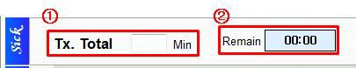

### ① Tx. Total: Tx. “Total” denotes the total duration of a care session. You can modify this before a care session, but not during a care session.

② Remain: The remaining time for a session timeout is displayed here during a session.

1. **How to operate or modify the Cervical Spine Action.**

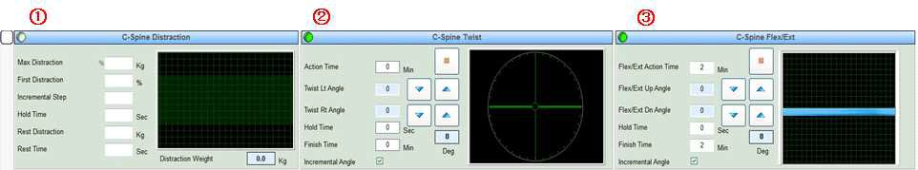

① Set up or display C-Spine Distraction functions here.

② Set up or display C-Spine Twist functions here.

③ Set up or display Cervical Spine Flex/Ext functions here.

1. 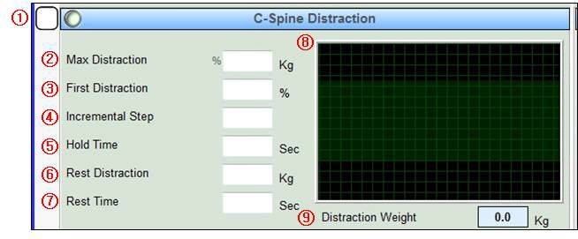Features and operation of C-Spine Distraction

① This box shows whether the C-Spine Distraction mode is enabled.

If this box is checked, the mode is activated.

② Max Distraction: This shows the Maximum Distraction you set up.

It is displayed in kg and can be modified during action. (Enter a value from

### 0 to 50 from the keyboard.)

③ First Distraction: This shows the Initial Distraction you set up.

It is displayed in Kg and can be modified during action. (Enter a value from 0 to 99 from the keyboard.)

④ Incremental Steps: This shows the Incremental Steps.

This can be modified during action. (Enter a value from 0 to 9 from the keyboard.)

⑤ Hold Time: This shows the duration of a pause (sec) at the maximum distraction.

It can be modified during action. (Enter a value from 0 to 99 from the keyboard.)

⑥ Rest Distraction: This shows the distraction force during a rest.

It is displayed in kg and can be modified during action. (Enter a value from 0 to 50 from the keyboard.)

⑦ Rest Time: This shows the duration of a pause (sec) in Rest Distraction.

It can be modified during action. (Enter a value from 0 to 99 from the keyboard.)

⑧ The changes in distraction are displayed in real time.

⑨ The changes in distraction are displayed in numbers in real time.

1. Descriptions of C-Spine Twist functions

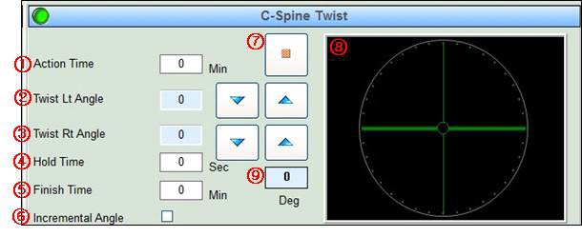

① Action Time: Enter from the keyboard the start time of the twist action.

② Twist Lt Angle: Set up the Left Twist angles with the ▽△ buttons.

③ Twist Rt Angle: Set up the Right Twist angles with the ▽△ buttons.

⑤ Hold Time: Enter the duration of a pause (sec) at the set angle from the keyboard.

⑤ Finish Time: Enter the end time (min) of C-Spine Twist Action.

⑥ Incremental Angle: Select an Incremental Angle step with the mouse.

⑦ Click this to stop the Twist Action.

⑧ Measured Twist Angle: This shows the Twist Angles in real time.

1. Features and operation of Cervical Spine Flex/Ext

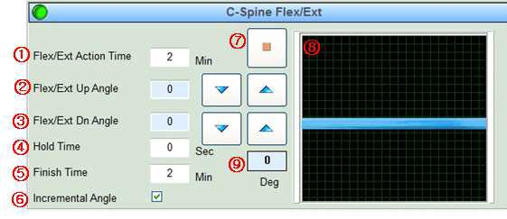

① Flex/Ext Action Time: Enter the start time of C-Spine Flexion/Extension here. (Enter it in units of a minute from the keyboard.)

② Flex/Ext Up Angle: Set up the Flexion Exercise Action angles with the ▽△ buttons. (Enter from 0 to 10 degrees in units of 1 degrees.)

③ Flex/Ext Dn Angle: Set up the Extension Exercise Action angles with the ▽△ buttons. (Enter from 0 to 15 degrees in units of 1 degrees.)

⑤ Hold Time: Enter the duration of a pause (sec) in a Flex/Ext state. (Enter a time from 0 to 99 minutes from the keyboard.)

⑤ Finish Time: Enter the end time (min) of a Flex/Ext Action. (Enter a time from 0 to 99 minutes from the keyboard.)

⑥ Incremental Angles: Here you can set the action mode up to the set angle. (When you select this mode, the device angle starts at 1 degrees and is added by 1 degrees until it reaches the set angle, and from this moment the angle remains the same. When you deselect this mode, the set angle is applied from the start.)

3. How to operate or modify the screen for Cervical Spine Action

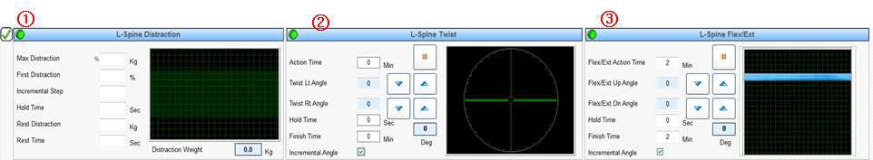

1. Set up or display the functions of Lumbar Spine Distraction here.
2. Set up or display the functions of Lumbar Spine Twist here.
3. Set up or display the functions of Lumbar Spine Flex/Ext here.

### (1) Features and operation of Lumbar Spine Distraction

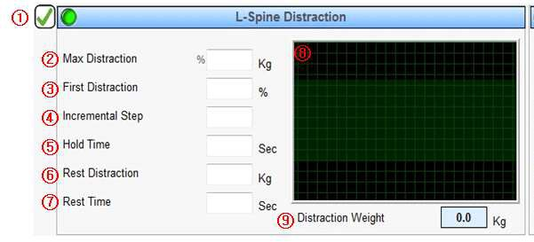

① This box shows whether the L-Spine Distraction mode is enabled.

If this box is checked, the mode is activated.

② Max Distraction: This shows the Maximum Distraction you set up.

It is displayed in kg and can be modified during action. (Enter a value from 0 to 50 from the keyboard.)

③ First Distraction: This shows the Initial Distraction you set up.

It is displayed in kg and can be modified during action. (Enter a value from 0 to 99 from the keyboard.)

④ Incremental Steps: This shows the Incremental Steps.

This can be modified during action. (Enter a value from 0 to 9 from the keyboard.)

⑤ Hold Time: This shows the duration of a pause (sec) at the maximum distraction. It can be modified during action. (Enter a value from 0 to 99 from the keyboard.)

⑥ Rest Distraction: This shows the distraction force during a rest.

It is displayed in kg and can be modified during action. (Enter a value from 0 to 50 from the keyboard.)

⑦ Rest Time: This shows the duration of a pause (sec) in Rest Distraction.

It can be modified during action. (Enter a value from 0 to 99 from the keyboard.)

⑧ The changes in distraction are displayed in real time.

⑨ The changes in distraction are displayed in numbers in real time.

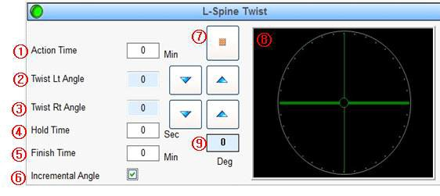(2) Descriptions of L-Spine Twist functions

### ① Action Time: Enter from the keyboard the start time of the twist action.

② Twist Lt Angle: Set up the Left Twist angles with the ▽△ buttons.

③ Twist Rt Angle: Set up the Right Twist angles with the ▽△ buttons.

④ Hold Time: Enter the duration of a pause (sec) at the set angle from the keyboard.

⑤ Finish Time: Enter the end time (min) of an L-Spine Twist Action.

⑥ Incremental Angles: Select an Incremental Angles step with the mouse.

⑦ Click this to stop the Twist Action.

⑧ Measured Twist Angle: This shows the Twist Angles in real time.

Descriptions of L-Spine Flex/Ext functions(Pelvic(hip joint)

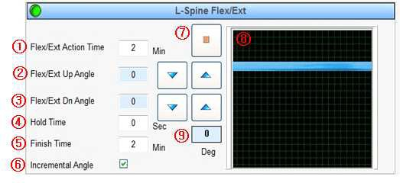

① Flex/Ext Action Time: Enter the start time of L-Spine Flexion/Extension here. (Enter it in units of a minute from the keyboard.)

② Flex/Ext Up Angle: Set up the Flexion Exercise Action angles with the ▽△

buttons (Enter from 0 to 10 degrees in units of 5 degrees).

③ Flex/Ext Dn Angle: Set up the Extension Exercise Action angles with the ▽△ buttons (Enter from 0 to 20 degrees in units of 5 degrees).

④ Hold Time: Enter the duration of a pause (sec) in a Flex/Ext state. (Enter a time from 0 to 99 minutes from the keyboard.)

⑤ Finish Time: Enter the end time (min) of a Flex/Ext Action. (Enter a time from 0 to 99 minutes from the keyboard.)

⑥ Incremental Angles: Here you can set the action mode up to the set angle. (When you select this mode, the device angle starts at 5 degrees and is added by 5 degrees until it reaches the set angle, and from this moment the angle remains the same. When you deselect this mode, the set angle is applied from the start.)

1. L-Compression Mode

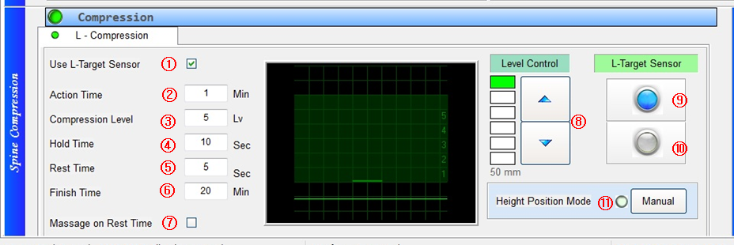

① Use L-Target Sensor : Enter the selecting whether to use the target sensor of lumbar spine

② Action Time : Enter the time at which the cushion ball starts to move up and down for compression of the lumbar spine(0-99 input available)

③ Compression Level : Enter the vertical height of move up and down of the cushion ball(10-55mm)

④ Hold Time : Enter the time to keep the compression state by cushion ball

⑤ Rest Time : Enter the time to keep the relax time after move down of cushion ball

⑥ Finish Time : Enter the time at which the cushion ball finishes to move up and down for compression of the lumbar spine(0-99 input available)

⑦ Massage on Rest Time : Enter the selecting whether to use the massage function by cushion ball during rest time.

⑧ Level Control : Enter the vertical height of move up and down of the cushion ball(10-55mm)

⑨ L-Target Sensor : The blue light signal is when the detecting ensor is recognized on lumbar spine.

⑩ L-Target Sensor : The red light signal is when the detecting sensor is out of the allowable range

⑪ Height Position Mode : If the detecting sensor goes beyond the allowable range during treatment time, the height control motor is automatically activated to position the detecting sensor.

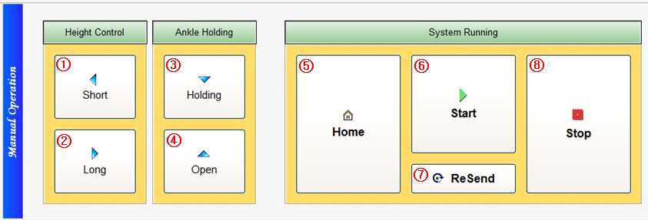5) A window to make a final setup to start a treatment session.

① Short (Height Control): This is a button to reduce the bed length to match it with the patient’s height after laying the patient on the bed.

② Long (Height Control): This is a button to extend the bed length to match it with the patient’s height after laying the patient on the bed.

③ Holding (Ankle Holding): This is a button to hold the patient’s ankles after laying the patient on the bed.

- The ankle holder will be automatically released when the treatment is over.

④ Open (Ankle Holding Release): This is a button to release the ankle holder.

⑤ Home: To reset all the actions to the original state, click the Stop button, check the device and then click the Home button.

⑥ Start: This is a button to start the device (treatment).

- Make sure the patient is held properly and then press the Start button.

⑦ ReSend: To apply the changes in the treatment conditions on the Status Display screen or during a care session, go to the Status Display screen and press this button.

⑧ Stop button: Use this to stop the device.

When you detect danger or an abnormal state of the device, press this button to stop all the actions of the device. (This works as an emergency button.)

**6. How to Operate the Setup Window**

1. A window for malfunction tests and manual checkups

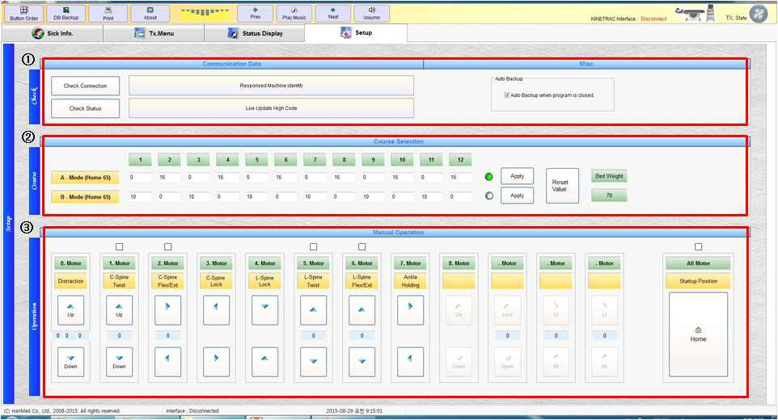

① Communication Data: Check the connection of the device and PC.

② This is a window to set up the pattern (course) of Comp Ma. Mode (Compression Moving Action Mode).

③ This is a button to check for the operation of each functional motor of the device.

1. Malfunction tests and manual checkups

- When you detect any error or malfunction, use the following buttons to display the setup window.

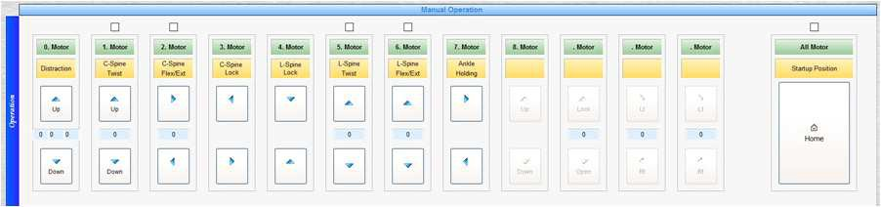

Figure - Motor operation buttons

- Turn on the power and open the Manual Operation window on the PC monitor to test the motor movements for each function. Check if the motors are working well and check for any errors through the numbers between the buttons.

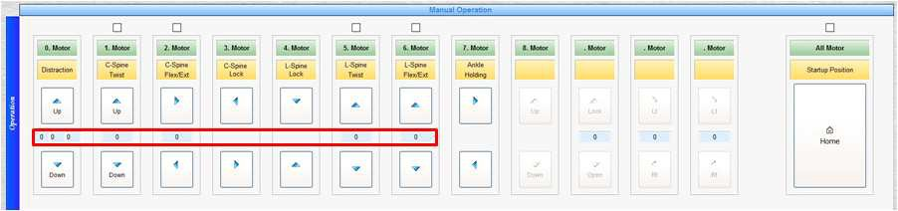

Figure - A window to check for the sensor pulse of a motor while the motor is running.

① Check if the numbers increase or decrease properly according to the functional movements of each motor.

② When you find no errors in the motor movements and sensor pulse generation, press the Home button. Then all the functions are aligned to get ready for operation.

③ If a motor pulse is not generated, contact the supplier.

* 1. Window to manually operate the motors.

1. Home: To start from the beginning, click **Home**.

|  |  |  |  |
| --- | --- | --- | --- |
| No. | Motor | Home | Operation |
| 0. Motor | Distraction | 0 | Distraction |
| 1. Motor | C-Spine Twist | 0 | Cervical Spine Twist |
| 2. Motor | C-Spine Flex/Ext | 0 | Cervical Spine Flexion/Extension |
| 3. Motor | C-Spine Lock | - | Cervical Spine Lock/Open |
| 4. Motor | L-Spine Lock | - | Lumbar Spine Lock/Open |
| 5. Motor | L-Spine Twist | 0 | Lumbar Spine Twist |
| 6. Motor | L-Spine Flex/Ext | 0 | Extension/Flexion of Pelvic (hip joint) |
| 7. Motor | Ankle Holding | - | Ankle holding |
| 8. Motor | Height | - | Height Short & Long Control |
| 9. Motor | Compression | 0 | Compression  (Distraction With Target Lordosis Of L-Spine) |



**Important! This system requires regular maintenance. To maintain sensitive electronics, use electrical /electronic protection such as a surge suppressor.**

* 1. Do not dissemble, modify or redesign the device without first consulting with Hanmed Inc.
  2. Doing so may cause equipment malfunction and warranty invalidation.
  3. Do not remove the safety cover.
  4. Do not have the device repaired by a technician not authorized by Hanmed Inc.
  5. Consult with the authorized service provider (from Hanmed Inc.) if you have any questions.
  6. Do not service while in use with the patient.

## General

1. Do not connect or re-connect the system to an electrical power source before confirming that the voltage and frequency (Hz) are compatible with this equipment.
2. Use a soft, lint-free towel to wipe the touch screen.
3. Use cleansers containing ammonia (recommended).
4. Periodically clean the surface of the table with a non-toxic bacteria remover.
5. Remove dust with a vacuum cleaner once a week.
6. Avoid excessive humidity.
7. Do not put any liquid or objects on or into the console.
8. Ensure that electrical cords are not damaged, and do not use a damaged cord.

## Weekly

1. Check for errors or malfunctions on the **Setup** screen.
2. Check for damaged, cut or exposed cords around the control box and consol.
3. Check the connection status within the control box.
4. Check to ensure the nodes (fastening nuts and bolts) are tightened and secure.
5. Check the ankle fixer to ensure it is secure.

## Malfunction Test and Manual Checkup

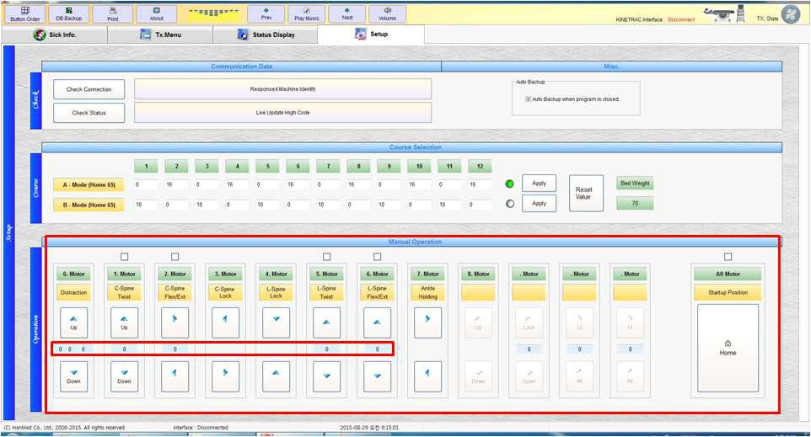

* 1. Turn on the power and test the operation of motors for each function listed on the **Manual Operation** screen.
  2. To confirm normal operation, click on **Home**, and then complete the arrangement and preparation of all functions.

Sensor Pulse Numbers during the Operation of the Motors

1. When testing the **Function** motors, check to determine whether the numbers located in the center portion increase and decrease correctly.
2. When **Function** motors and **Sensor Pulse** numbers are working properly, click on the **Home** button. Each function is now set.
3. Contact the supplier or authorized agent if the Sensor Pulse Numbers do not display on the screen, or display incorrectly.

## Disposal



When this system ceases operation permanently, it should be carefully disassembled and disposed of by authorized institutions or sent to Hanmed Inc. In the bed unit, no harmful

or explosive materials are included-- they are made primarily of aluminum, iron, and plastic.

For the control box, contact the authorized representative of Hanmed Inc., or follow your institution's guidelines for proper disassembly and disposal of electronic components.



**Indicator/Possible Cause Corrective Action**

Error Code: Bad Copy Program. Please maker contact.

Please maker contact.

Error occurred when DB search. Rerun the DB file recovery.

PC and kinetrac DAVINCI devices and connection status is not. First, check the connection status

Check the connection status

First of all, HOME Please. HOME Please.

First of all, Fixing the ankle. Fixing the ankle.

Failed to Backup. Check that the HDD is able to read and write.



**※Note:** This system should not be used adjacent to or stacked with other equipment.

**※Note:** The mobile RF communications equipment can effect medical electrical equipment.

|  |  |  |
| --- | --- | --- |
| Electromagnetic emission | | |
| The **kinetrac DAVINCI** is intended for use in electromagnetic environment specified below. The customer or the user of the **kinetrac DAVINCI** should assure that it is used in such an environment. | | |
| Emission test | Compliance | Electromagnetic environment - guidance |
| RF emissions – CISPR11 | Group 1 | The **kinetrac DAVINCI** uses RF energy only for its internal function. Therefore, its RF emissions are very low and are not likely to cause any interference in nearby electronic equipment. |
| RF emissions- CISPR11 | Class A | The **kinetrac DAVINCI** is suitable for use in all establishments (i.e. hospitals, doctors practice etc.) other than domestic. **kinetrac DAVINCI** is intended for professional use only. |
| Harmonic emissions IEC 61000-3-2 | Class A |  |
| V o l t a g e f l u c t u a t i o n s / f l i c k e r emissions IEC6100-3-3 |  |  |

|  |  |  |  |  |
| --- | --- | --- | --- | --- |
| Electromagnetic immunity | | | | |
| The **kinetrac DAVINCI** is intended for use in the electromagnetic environment specified below. The customer or the user of the **kinetrac DAVINCI** should assure that it is used in such an environment. | | | | |
| I M M U N I T Y  test | IEC 60601 LEVEL | TEST | Compliance level | Electromagnetic environment – guidance |
| C o n d u c t e d RF  I E C 61000-4-6  Radiated RF  I E C 61000-4-3 | 3 Vrms  150 kHz MHz  3 V/m  80 MHz to GHz | to 80  2,5 | [V1] V  [E1] V/m | Portable and mobile RF communications equipment should be used no closer to any part of the **kinetrac DAVINCI**, including cables, than the recommended separation distance calculated from the equation applicable to the frequency of the transmitter.  **Recommended separation distance**  80MHz to 800 MHz 800MHz to 2,5GHz  -where P is the maximum output power rating of the transmitter in watts (W) according to the transmitter manufacturer and d is the recommended separation distance in meters (m).  -Field strengths from fixed RF transmitters, as determined by an electromagnetic site survey, should be less than the  -Interference may occur in the vicinity of equipment marked with the following symbol: |
| NOTE 1 At 80 MHz and 800 MHz, the higher frequency range applies.  NOTE 2 These guidelines may not apply in all situations. Electromagnetic propagation is affected by absorption and reflection from structures, objects and people. | | | | |
| a Field strengths from fixed transmitters, such as base stations for radio (cellular/cordless) telephones and land mobile radios, amateur radio, AM and FM radio broadcast and TV broadcast cannot be predicted theoretically with accuracy. To assess the electromagnetic environment due to fixed RF transmitters, an electromagnetic site survey should be considered. If the measured field strength in the location in which the **kinetrac DAVINCI** is used exceeds the applicable RF compliance level above, the **kinetrac DAVINCI** should be observed to verify normal operation. If abnormal performance is observed, additional measures may be necessary, such as re-orienting or relocating the **kinetrac DAVINCI**.  b Over the frequency range 150 kHz to 80 MHz, field strengths should be less than [V1] V/m. | | | | |

|  |  |  |  |
| --- | --- | --- | --- |
| Recommended separation distances between  portable and mobile RF communications equipment and the **kinetrac DAVINCI** | | | |
| The **kinetrac DAVINCI** is intended for use in an electromagnetic environment in which radiated RF disturbances are controlled. The customer or the user of the **kinetrac DAVINCI** can help prevent electromagnetic interference by maintaining a minimum distance between portable and mobile RF communications equipment(transmitters) and the **kinetrac DAVINCI** as recommended below, according to the maximum output power of the communications equipment. | | | |
| Rated maximum output power of transmitter W | Separation distance according to frequency of transmitter m | | |
| 150 kHz to 80 MHz | 80 MHz to 800 MHz | 800 MHz to 2,5 GHz |
| 0.01 |  |  |  |
| 0.1 |  |  |  |
| 1 |  |  |  |
| 10 |  |  |  |
| 100 |  |  |  |
| For transmitters rated at a maximum output power not listed above, the recommended separation distance d in meters (m) can be estimated using the equation applicable to the frequency of the transmitter, where P is the maximum output power rating of the transmitter in watts (W) according to the transmitter manufacturer.  NOTE 1 At 80 MHz and 800 MHz, the separation distance for the higher frequency range applies.  NOTE 2 These guidelines may not apply in all situations. Electromagnetic propagation is affected by absorption and reflection from structures, objects and people. | | | |

|  |  |  |  |
| --- | --- | --- | --- |
| Electromagnetic immunity | | | |
| The **kinetrac DAVINCI** is intended for use in the electromagnetic environment specified below. The customer or the user of the **kinetrac DAVINCI** should assure that it is used in such an environment. | | | |
| IMMUNITY test | IEC 60601  test level | Compliance level | Electromagnetic environment – Guidance |
| Electrostatic discharge (ESD) IEC 61000-4-2 | ± 6 kV contact  ± 8 kV air |  | Floors should be wood, concrete or ceramic tile. If floors are covered with synthetic material, the relative humidity should  be at least 30 %. |
| Electrical fast transient/burst IEC 61000-4-4 | ± 2 kV for power supply lines  ± 1 kV for input/output lines |  | Mains power quality should be that of a typical commercial or hospital environment. |
| Surge  IEC 61000-4-5 | ± 1 kV line(s) to line(s)  ± 2 kV line(s) to earth |  | Mains power quality should be that of a typical commercial or hospital environment. |
| Voltage dips, short interruptions and  voltage variations on power supply input lines  IEC 61000-4-11 | <5 % UT  (>95 % dip in UT) for 0,5 cycle  40 % UT  (60 % dip in UT) for 5 cycles  70 % UT  (30 % dip in UT) for 25 cycles  <5 % UT  (>95 % dip in UT) for 5 s |  | Mains power quality should be that of a typical commercial or hospital environment. If the user of the  [ME EQUIPMENT or ME  SYSTEM] requires continued operation during power mains interruptions, it is recommended that the [ME EQUIPMENT or ME SYSTEM] be powered from an uninterruptible power  supply or a battery. |
| Power frequency (50/60 Hz)  magnetic field IEC 61000-4-8 | 3 A/m |  | Power frequency magnetic fields should be at levels characteristic of a typical location in a typical commercial or hospital environment. |
| NOTE UT is the ac. mains voltage prior to application of the test level. | | | |

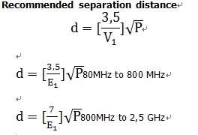

|  |  |  |  |
| --- | --- | --- | --- |
| Electromagnetic immunity | | | |
| The **kinetrac DAVINCI** is intended for use in the electromagnetic environment specified below. The customer or the user of the **kinetrac DAVINCI** should assure that it is used in such an environment. | | | |
| I M M U N I T Y  test | IEC 60601 TEST LEVEL | Compliance level | Electromagnetic environment – guidance |
| Conducted RF IEC 61000-4-6  Radiated RF IEC 61000-4-3 | 3 Vrms  150 kHz to 80 MHz  3 V/m  80 MHz to 2,5 GHz | [V1] V  [E1] V/m | Portable and mobile RF communications equipment should be used no closer to any part of the **KINETRAC 99000**, including cables, than the recommended separation distance calculated from the equation applicable to the frequency of the transmitter.  **Recommended separation distance**  80MHz to 800 MHz 800MHz to 2,5 GHz  where P is the maximum output power rating of the transmitter in watts (W) according to the transmitter manufacturer and d is the recommended separation distance in meters (m).  Field strengths from fixed RF transmitters, as determined by an electromagnetic site survey, should be less than the  compliance level in each frequency rangeb.  Interference may occur in the vicinity of equipment marked with the following symbol: |
| NOTE 1 At 80 MHz and 800 MHz, the higher frequency range applies.  NOTE 2 These guidelines may not apply in all situations. Electromagnetic propagation is affected by absorption and reflection from structures, objects and people. | | | |
| a Field strengths from fixed transmitters, such as base stations for radio (cellular/cordless) telephones and land mobile radios, amateur radio, AM and FM radio broadcast and TV broadcast cannot be predicted the oretically with accuracy. To assess the electromagnetic environment due to fixed RF transmitters, an electromagnetic site survey should be considered. If the measured field strength in the location in which the **kinetrac DAVINCI** is used exceeds the applicable RF compliance level above, the**kinetrac DAVINCI** should be observed to verify normal operation. If abnormal performance is observed, additional measures may be necessary, such as re-orienting or relocating the **kinetrac DAVINCI**.  b Over the frequency range 150 kHz to 80 MHz, field strengths should be less than [V1] V/m. | | | |

|  |  |  |  |
| --- | --- | --- | --- |
| Recommended separation distances between  portable and mobile RF communications equipment and the **kinetrac DAVINCI** | | | |
| The **kinetrac DAVINCI** is intended for use in an electromagnetic environment in which radiated RF disturbances are controlled. The customer or the user of the **kinetrac DAVINCI** can help prevent electromagnetic interference by maintaining a minimum distance between portable and mobile RF communications equipment (transmitters) and the **kinetrac DAVINCI** as recommended below, according to the maximum output power of the communications equipment. | | | |
| Rated maximum output power of transmitter W | Separation distance according to frequency of transmitter m | | |
| 150 kHz to 80 MHz | 80 MHz to 800 MHz | 800 MHz to 2,5 GHz |
| 0.01 |  |  |  |
| 0.1 |  |  |  |
| 1 |  |  |  |
| 10 |  |  |  |
| 100 |  |  |  |
| For transmitters rated at a maximum output power not listed above, the recommended separation distance d in meters (m) can be estimated using the equation applicable to the frequency of the transmitter, where P is the maximum output power rating of the transmitter in watts (W) according to the transmitter manufacturer.  NOTE 1 At 80 MHz and 800 MHz, the separation distance for the higher frequency range applies.  NOTE 2 These guidelines may not apply in all situations. Electromagnetic propagation is affected by absorption and reflection from structures, objects and people. | | | |

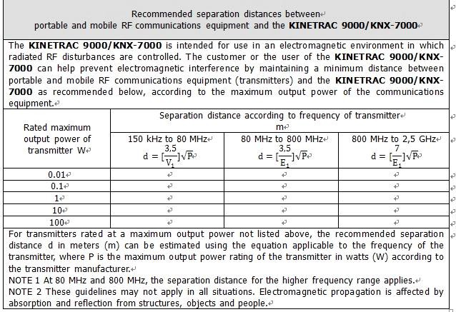



## Dimensions and Weight

- **Main Body** (Unit: mm)

-

-**Weight**: about 450 kg

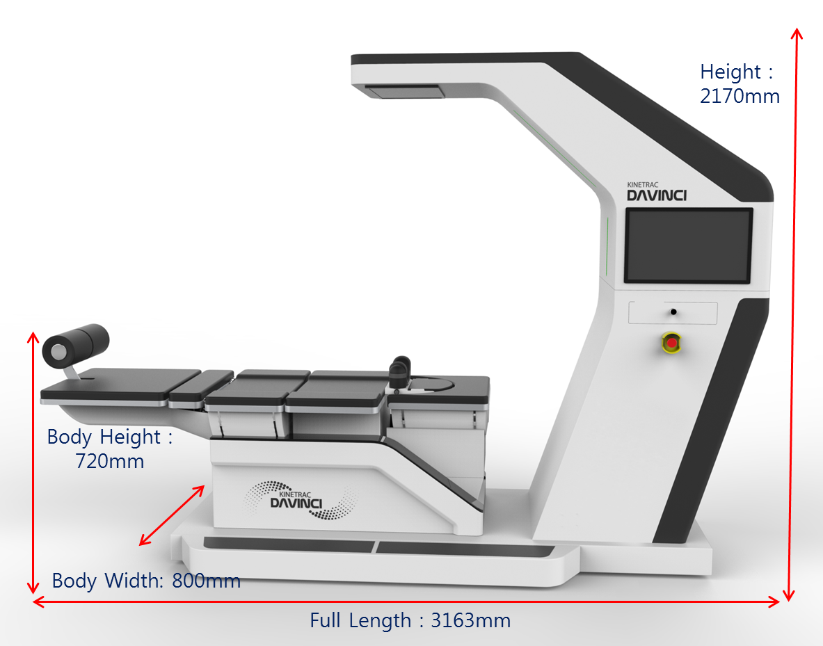

|  |  |  |  |  |
| --- | --- | --- | --- | --- |
| Item | Dimension (mm) | | | Weight (kg) |
| Width | Length | Height |
| Main Body | 800 | 3163 | 2170 | 450 |

## Electrical rating

110V/60Hz, 230V/50Hz

## Main Body

▪ Distraction(C-spine, L-Spine)

Traction power : Max 45Kg ± 10%

Setting power : ±2Kg,

▪ C-Spine Twist

Rotation angle : Rt & Lt 0~20° ±3 °

▪ C-Spine Flexion/Extension

Extension angle : 0°~ 15° ±2°

▪ L-Spine Twist

Rotation angle : Rt & Lt 0~20° ±3°

▪ Pelvic(hip joint) : Flexion/Extension

Extension angle : 0~25° ±3°

▪ L-Spine Compression

Lumbar Spine rise action : 50mm ±10mm

▪ Height Controller for Lower Body

Height modification range : 0~200mm ±5mm

## Control Box

Monitor

* + - Resolution :1920 * 1080
    - Size :21inc Computer
    - OS : Window XP Service Pack2 or higher
    - RAM :2Gb or higher
    - HDD :150Gb or higher Software version :
    - V7.8



1. Service related phone calls, visits, and general management items should be accurately recorded and classified.
2. Submit the service record to the authorized representative of Hanmed Inc. when

requested. If no service record exists, or is poorly and/or inaccurately maintained, the warranty is invalid.

1. Refer to the log below to maintain a proper (appropriate) service record.

**Kinetrac DAVINCI Service Maintenance/ Cleaning Log**

|  |  |  |  |
| --- | --- | --- | --- |
| **Service Date** | **Technician Servicing** | **Service Order**  **#** | **Technician Notes** |
|  |  |  |  |
|  |  |  |  |
|  |  |  |  |
|  |  |  |  |
|  |  |  |  |
|  |  |  |  |
|  |  |  |  |
|  |  |  |  |
|  |  |  |  |
|  |  |  |  |
|  |  |  |  |
|  |  |  |  |
|  |  |  |  |



* 1. This system is provided under warranty by Hanmed Inc. for one year from the date of purchase, provided that the following conditions are adhered to by the purchaser within the warranty period:
     1. The equipment is used in an appropriate manner as set out in this

**User's Manual** and other relevant training/instructional materials;

* + 1. The equipment is operated only by personnel trained and/or authorized by Hanmed Inc.;
    2. A regular maintenance schedule is followed, with reference to the **Service / Cleaning Log** described above;
    3. All repairs or necessary servicing not directly pertaining to Item C immediately above are undertaken by technicians authorized or approved by Hanmed Inc.
  1. The warranty is invalid due-- but not limited to--the following situations:
     1. Arbitrary (not in an appropriate manner) usage by the owner.
     2. Installation and/or use of parts unauthorized or approved by Hanmed Inc.
     3. Incorrect usage of individual components comprising the equipment.
     4. Damage due to natural causes ("Acts of God") such as fire or flood.
     5. Damage due to negligence, accident, or misuse.
     6. Unauthorized replacement of the fuse or circuit breaker.
  2. The warranty for the equipment expires one year following the date of purchase. Any and all costs incurred after the expiration date are the responsibility of the purchaser.

Provided that the terms of this warranty are adhered to, the manufacturer (Hanmed Inc.) is responsible for parts and labor due to manufacturing defects or equipment malfunction during the

warranty period.

1. Services and Warranty

This warranty covers Kinetrac Davinci and its components for one year from the date of shipment.

The following warranty policies are applied to all the products manufactured by Hanmed Inc. If an error occurs in the product in normal operating mode, Hanmed Inc. will provide repair or replacement services for the defective components of Kinetrac Davinci to the extent which is acknowledged by Hanmed Inc. at no cost to the owner. However, for any defects or errors that are found after the warranty period or that are caused by the customer, all the costs arising from that incident shall be borne by the customer.

Receiving a repair or maintenance service from any technician not authorized by Hanmed Inc. shall terminate the warranty immediately. Warranty of Kinetrac Davinci is attached as an appendix to this booklet.

If a Kinetrac Davinci and its accessories are not maintained properly through the periodic inspection and precautions, the warranty of the corresponding device shall be terminated immediately.

- Goods or services not covered by the warranty of Kinetrac Davinci

* A failure of the device or accessories caused by not following the usage instructions from the manufacturer.
* A failure of the device or accessories due to an incorrect installation or a use of products or parts not authorized by Hanmed Inc.
* A failure of the device or accessories due to an improper application of any component.
* A damage caused by accident, fire, acts of God or negligence.
* A damage caused by a fuse or circuit breaker replacement.
* The leather sheet of the Chest Harness.

The manufacturer can change any of the specifications of the products without prior notice to prospective buyers. If any changes are made to the device by the manufacturer, this is to allow for the software upgrades, system stability, convenience, usability for the customers and improved performance of the device.

The performance improvements are made at the expense of the manufacturer to meet the customers’ performance requirements.

Hanmed Inc. will provide product software free of charge, but the costs of structural changes or component replacements of the device shall be borne by the customer. Most of these enhanced functions can be purchased with a system upgrade. Please contact our sales representatives for more information.

Conditions of Original Warranty

When an error occurs in the product due to the fact that you installed the product or connected it to an electrical circuit in a manner other than as set forth by the Company, the guarantee scheme established by the company is invalid and not applied. So technicians who install the product shall read the instruction manual thoroughly before installing the product. Terms and conditions for the product is implemented in accordance with all routine maintenance procedures, thus all repairs, modifications or changes shall follow the specifications of the Kinetrac Davinci manufacturer.

Technicians and agents for Kinetrac Davinci shall provide the customers with the user’s manual, records and services in accordance with routine maintenance procedures.

If the device is not working because a customer handled or managed it in a way other than as described in the user’s manual, the manufacturer shall have the distributor check the reason and make the device work. In such a case, however, the expenses are not covered by the warranty set forth by the company.

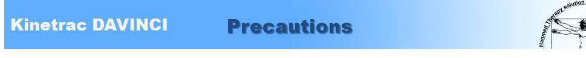

**Warning! Usage of the system is limited to authorized physical therapists, spine specialists or other professionals. Usage requires authorization from a licensed doctor. General**

* 1. A doctor or a therapist should inform patients how to operate the emergency stop in the unlikely event that the patient should feel uncomfortable.
  2. After providing instructions to new patients, watch to see whether there is an abnormal noise coming from the device, or whether the patient feels comfortable while the device is working.
  3. If you find an abnormality in the system, or the patient looks uncomfortable during its operation, take proper measures including modifying the care program or temporarily stopping the equipment.
  4. If the equipment stops due to a power failure, untie the Chest Harness (Upper Body Fastener Belt) and pelvis belt. Patient sit up release the ankles from the ankle holder, and safely release the patient.
  5. Never alter this equipment without permission from Hanmed Inc. or its authorized agent.
  6. If the equipment is broken, mark the broken part and have an authorized expert repair it.
  7. If a patient feels uncomfortable during its operation, stop to operation. And choose another Care procedure(pattern)that is better for the patient, and then resume.
  8. Do not touch and control the main body or power, during operation of the equipment.
  9. The equipment must not be leaned on when in operation.
  10. Before beginning a care pattern, ensure that equipment is Home position.
  11. Avoid exterior shock to the equipment.
  12. When touching the screen to operate the system, gently touch icons or buttons one at a time with the fingers. Do not press more than 2 icons or buttons simultaneously.
  13. The education for using the device is carried out at the first installation in the site. And then if you have any questions for device usage or you need a service request for education, please call and mail to the Hanmed Inc or authorized agent.

14. The maximum allowable body weight is 135kg.

## Specific

**Danger/ Warning! If one of the conditions below is relevant to your patient(s), the operator must be careful when setting the angle of the bed:**

1. High blood pressure
2. Eye problems including glaucoma or diabetes-related diseases
3. Esophageal hiatus hernia
4. Weak bones (osteoporosis), recently broken and untreated bones. Marrow inserted bones.
5. Artificial hip, knee joint
6. Surgically transplanted orthopedic support device
7. Encephalosclerosis
8. Spinal injury
9. Cardiac or circulatory problems that need treatment
10. Substantially swollen joints
11. Pregnant
12. Senior citizens





B-101, 80-121, Golden Root-ro, Juchon-myeon, Gimhae-si, Gyeongsangnam-do, 50969, KOREA

• Phone +82-55-331-0575 • Fax +82-55-331-0547

[**www.hanmed.net**](http://www.hanmed.net/) Technical Support  [kinetrac@naver.com](mailto:kinetrac@naver.com)

# Warranty



Our technicians have invested a great deal of time and effort in this product. This product has passed strict quality control and inspection. In the case of a spontaneous failure or a failure due to defects from the manufacturer, visit the store where you purchased the product or the headquarters carrying the warranty. Our After-sales Service Team will repair the product with their utmost efforts.

◈ **Warranty Guide** ◈

**-Free of charge services**

In the case of a device failure due to a manufacturing defect, free repair services are offered for 12 months from the date of purchase.

**-Paid repair services**

* Damage due to natural disasters or power failure.
* Damage due to the user's carelessness even during the warranty period.
* Damage due to the user's alteration of, or internal changes to the product, or user's repair trial.
* When the warranty is expired.

**-Compensation standards**

* Compensation standards for repair, replacement or refund of the products are subject to the Notifications from the Ministry of Strategy and Finance.

|  |  |  |  |
| --- | --- | --- | --- |
| Product Name | **kinetrac DAVINCI** | Model Name | **kinetrac-9900** |
| Purchase  Date |  | Warranty  Period | One year from the purchase  date |
| Name |  | Phone |  |
| Address |  | Serial  Number |  |
| Purchase Store |  | Location of  Store |  |

Please check the manual prior to contacting the service center.

-Requests for services: Contact the store where you purchased the product or Hanmed Inc. (except on holidays)

Tel ＋82-55- 331-0575 Fax ＋82-55- 331-0575

-e-mail : [kinetrac@naver.com](mailto:kinetrac@naver.com)